2026 Campaign emails
Greater St. louis region

epledge email templates for united way of greater st. louis

This document contains email messaging for your United Way of Greater St. Louis (UWGSL) Campaign. You will find:
- A Pre-kickoff email (does not contain pledge link) – WE RECOMMEND YOU SEND THIS INTERNALLY
- 3 different kickoff emails
- 2 basic reminder emails and 1 last day reminder
- A variety of focus area and special case emails

All pledge emails include the UWGSL Logo and a notice that the link is unique at the bottom, some have been removed from this document to cut down on its length.*

Reminder emails are only sent to employees who have not yet pledged in the current year. If you would like the emails to go to all employees, please be sure to let us know.
You are free to request changes to the subject lines of your email selections to better align with your campaign messaging. All emails are mobile friendly.

BANNER IMAGES
*For the purposes of this document, the images for each of these emails may vary in size. This is simply a formatting need so that you are able to see which image is connected to each email. In the emails that are sent, the image will be the same width as the email.

SENDER SPOOFING
It is possible to “spoof” the sender of these emails. Be aware that if you would like to spoof the sender, additional effort by your company’s IT team and testing is necessary. Due to most workplaces’ heightened cybersecurity, this is not recommended without testing.

Contents
PRE-KICKOFF EMAIL 2
KICKOFF EMAILS 3
KICKOFF OPTION 1 3
KICKOFF OPTION 2 5
KICKOFF EMAIL FROM EXECUTIVE 6
REMINDER EMAILS 8
REMINDER OPTION 1 8
REMINDER OPTION 2 9
LAST DAY REMINDER 10
EMAIL TO EXTEND CAMPAIGN 11
FOCUS AREA EMAILS 12
REASONS WE PARTNER 12
PEOPLE HELPED EMAIL 14
STRONG COMMUNITIES EMAIL 16
FINANCIAL STABILITY EMAIL 17
YOUTH SUCCESS EMAIL 18
HEALTH AND WELLBEING EMAIL 19
ESSENTIAL NEEDS EMAIL 20
Specific Circumstances Emails 21
EMAIL FROM EXECUTIVE 21
EMAIL TO LEADERSHIP LEVEL DONORS OPTION 1 22
EMAIL TO LEADERSHIP LEVEL DONORS OPTION 2 23
EMAIL TO LAST YEAR’S DONORS 24
EMAIL TO NON-DONORS 26

PRE-KICKOFF EMAIL
NO PLEDGE LINK – RECOMMENDED TO SEND INTERNALLY
REF# PKOSTL
From: United Way of Greater St. Louis <epledge@unitedwaystl.org>
Subject: The United Way of Greater St. Louis Community Campaign is Almost Here!

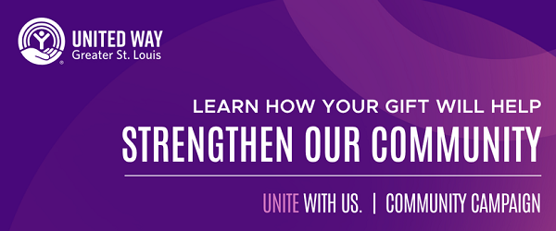

Hi <First Name>
As our region continues to face ongoing challenges, your support of United Way of Greater St. Louis brings hope and help to our neighbors across the St. Louis region. From providing food and clothing to offering education, job training, and counseling, United Way is here to help ensure individuals and families have the tools and support they need today and in the future. These efforts to overcome crisis as well as everyday challenges are how we strive to help our neighbors.
Together, we support more than one million people each year—showing what’s possible when we unite for the strength and stability of our region.
[Company Name] has an opportunity to join our efforts to make a difference once again – helping to create a better, brighter future for our local neighbors.
Each of us has the ability to spark change, and that impact multiplies through collective giving. As we work together around a shared commitment to uplift others, we can help our local neighbors stay safe, healthy and supported.
Next week, you will receive the official campaign kickoff email and a link to make your pledge to United Way. In the meantime, we encourage you to watch our mission video to see how our efforts in the community positively impact local individuals and families.
With your support, we hope to make 2026 a special year of giving, growing and helping our neighbors live here and thrive.

KICKOFF EMAILS

KICKOFF OPTION 1
REF# KO1STL
From: United Way of Greater St. Louis <epledge@unitedwaystl.org>
Subject: Let’s Celebrate and Cheer – United Way’s Campaign is Finally Here!

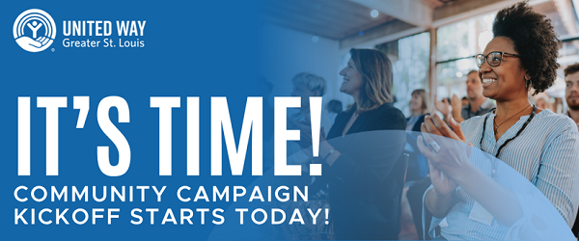
Hi <First Name>
We are excited to kick off the [Company Name] 2026 United Way of Greater St. Louis campaign. Because of your support, United Way of Greater St. Louis is able to help people who are continuing to navigate ongoing challenges – bringing hope and stability to neighbors across the region.
United, we help people meet everyday needs – supporting families through crisis, helping children learn and stay safe, and ensuring we have the resources and support to help feed, clothe and care for our neighbors in need.
United Way equips over 150 local nonprofits with vital funding and training resources to keep our region’s safety net responsive and resilient. Together, we are one community, one campaign, and one collective impact.
These efforts to overcome crisis as well as everyday challenges are how we strive to help our neighbors.
United Way and our nonprofit partners help people like:
- Veronica, who received help with housing and other essential resources after her home was destroyed by the storm.
- Juanita, who got access to reliable transportation and support systems after her husband passed away and she suffered an injury that limited her mobility.
- Nora, who after being diagnosed with autism, received early intervention services that helped her build confidence to interact with her peers and seek to learn new things.
We invite you to watch our mission video to learn more about how our community efforts make a difference.
You can also make a more significant, far-reaching impact by joining a Leadership Society with a gift of $1,000 or more. By doing so, you become a part of a network of more than 7,000 leaders in our region and receive access to additional benefits, including exclusive annual events and programming.
Unite with us to support individuals and families. Make a secure online gift to United Way of Greater St. Louis and join our collective impact.

Thank you for your commitment to empowering our neighbors.
Note: This donation link is unique to you to make pledging your gift easier. For your security, please do not forward this email.

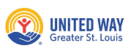

KICKOFF OPTION 2

REF# KO2STL
From: United Way of Greater St. Louis <epledge@unitedwaystl.org>
Subject: United We Help People Overcome Challenges

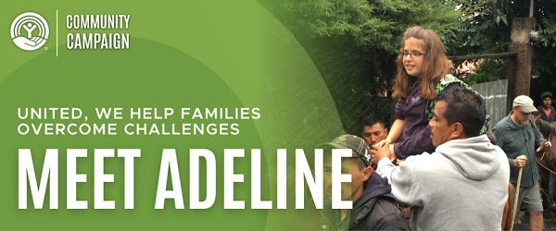

Hi <First Name>
Adeline was born with a developmental disability that was so rare it was hard for doctors to determine a specific diagnosis. Her condition caused struggles with her speech, motor, cognitive, and social skills. The fear of the unknown was unsettling for her family. Fortunately, a United Way of Greater St. Louis safety net agency provided support for Adeline and stability to the family in the midst of uncertainty.
They provided Adeline with quality occupational, physical, and speech therapy. Adeline’s progress exceeded her family’s expectations, and because of the support she received, she went on to overcome her challenges and achieve great things. She went on to sing in a local choir group and perform at several prestigious concerts, helped build a house in Guatemala for a family in need during a mission trip with her church, and currently works as a teacher’s aide, helping elementary school children learn about music and art.
United Way partners with over 150 nonprofits that help local neighbors like Adeline. Your support of United Way provides funding for our safety net of nonprofit partners, helping families like Adeline's.
Please join your colleagues today by contributing a secure, online gift to United Way of Greater St. Louis.
Thank you for uniting with us to change lives across the St. Louis region.

KICKOFF EMAIL FROM EXECUTIVE
REF# KOESTL
From: <Executive Name><epledge@unitedwaystl.org>
Subject: Unite With Us to Support Our Local Communities
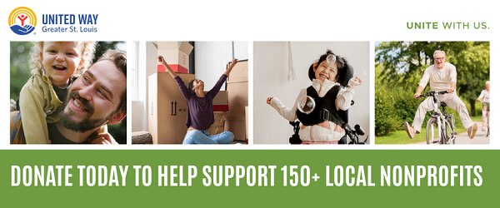
Hi <First Name>
Today, [Company Name] is excited to kick off its 2026 United Way of Greater St. Louis campaign, a coordinated community fundraising effort that helps United Way-funded nonprofits support our local neighbors. Because of your support, United Way of Greater St. Louis is one of the top United Way campaigns in the nation.
While we are proud of the strides that have been made in our region, there is still work to be done. The need for your continued support is urgent; 43% of households in our region are facing challenges to meet essential needs like rent, utilities, food, transportation, and medical costs.
Through your continued support of United Way, each year, we make a difference in the lives of over 1 million people in Missouri and Illinois; that’s 1 in 3 people across 16 counties supported by programs, services, and initiatives that help meet their immediate and long-term needs.
This commitment to investing in the stability of our region is why [Company Name] and I are proud to support United Way’s mission to help people live their best possible lives.
Your support makes a huge impact in moving our neighbors in need from crisis to stability, and that is why I am asking you to please join me in making a gift to support our local neighbors through United Way.
Every gift is deeply appreciated and contributes to the greater good of our region. You also have an opportunity to make a more significant, far-reaching impact by committing to a gift at the Leadership Giving Level of $1,000 or more. By doing so, you become a part of a network of more than 7,000 leaders in our region dedicated to creating lasting change and supporting our community.
Thank you for uniting with us and being a part of our efforts to create a better, brighter future for our local communities.
[Executive Name]
Note: This donation link is unique to you to make pledging your gift easier. For your security, please do not forward this email.

REMINDER EMAILS

REMINDER OPTION 1
REF# RE1STL
From: United Way of Greater St. Louis <epledge@unitedwaystl.org>
Subject: Inspire Hope and Community Impact by Supporting United Way

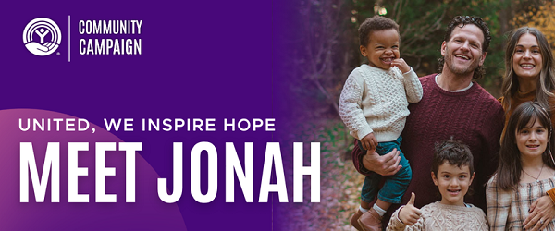
Hi <First Name>
Your support of United Way of Greater St. Louis sparks real, lasting change that helps our neighbors overcome challenges and thrive. Right now, the need for your support is still urgent; 43% of households in our region face challenges to meet essential needs like rent, utilities, food, transportation, medical costs, and more.
When you unite with us to help our local communities, you are investing in over 150 nonprofits that are helping our neighbors, like:
- Kim, who needed support for her two sons who were both diagnosed with autism.
- Jonah, who found a caring, loving family after being abandoned at birth.
- Jodie, who was looking for hope and care after an unexpected cancer diagnosis.
Your gift to United Way gives hope to thousands of people like Kim, Jonah, and Jodie.
There is also an opportunity to make a more significant, far-reaching impact by committing at the Leadership Giving level of $1,000 or more. By doing so, you become a part of a network of more than 7,000 leaders in our region and receive access to additional benefits, including exclusive annual events and programming.
Join your colleagues and support our efforts to make the St. Louis region a better place for our neighbors to live and thrive by making a secure online gift today.
Thank you for helping us empower our neighbors.

REMINDER OPTION 2
REF# RE2STL
From: United Way of Greater St. Louis <epledge@unitedwaystl.org>
Subject: Make a Meaningful Difference Through Your Support of United Way

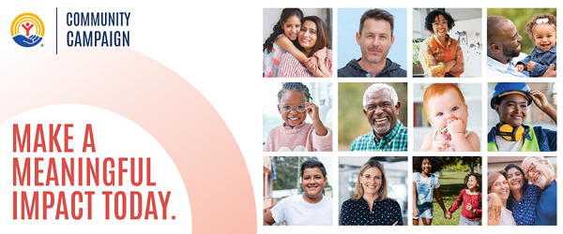
Hi <First Name>
As generous people like you continue to unite with us, we will see real, lasting change. United Way's impact on the community includes equipping over 150 local nonprofits with vital funding and training resources, operating the largest Volunteer Center in the region, and connecting local neighbors to providers of services through our 211 referral line.
United, we help individuals and families thrive.
Over the years, so many people have united behind our mission to help people live their best possible lives, and because of this commitment, United Way of Greater St. Louis remains one of the top United Way campaigns in the nation.
Your giving helps United Way meet immediate needs such as food, clothing, and transportation as well as long-term support such as youth programming, education, job training, and counseling.
Your continued support is crucial as our region faces ongoing, ever-changing challenges. Help us make a positive impact by pledging your gift today.
There is also an opportunity to make a more significant, far-reaching impact by committing at the Leadership Giving level of $1,000 or more. By doing so, you become a part of a network of more than 7,000 leaders in our region and receive access to additional benefits, including exclusive annual events and programming.

Thank you for helping our neighbors in need by supporting United Way.

LAST DAY REMINDER
REF# LDRSTL
From: United Way of Greater St. Louis <epledge@unitedwaystl.org>
Subject: Last Day to Support United Way!

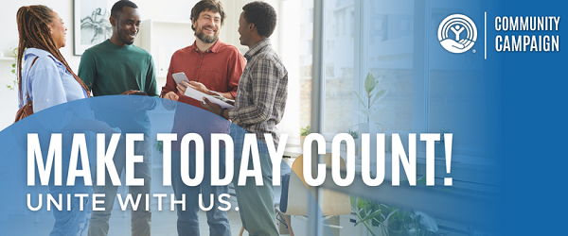

Hi <First Name>
Today is the final day of the [Company Name] 2026 United Way of Greater St. Louis community campaign, and support is crucial in helping us feed, clothe, and care for families across our region. Your support will provide funding and resources to nonprofits, programs, and services that help our local neighbors overcome ongoing challenges.
With your support, we will continue to:
- Help 1 in 3 people across 16 counties in Missouri and Illinois.
- Partner with over 150 local nonprofits that provide vital services to help individuals and families.
- Use 211 Powered by United Way of Greater St. Louis as a referral helpline to connect people to resources and services available in the community.
There is also an opportunity to make a more significant, far-reaching impact by committing at the Leadership Giving level of $1,000 or more. By doing so, you become a part of a network of more than 7,000 leaders in our region and receive access to additional benefits, including annual events and programming.
Please take this opportunity to make a secure, online gift. United, we have the opportunity to stabilize our region today, and for the future.

Thank you for being a part of our collective impact.

EMAIL TO EXTEND CAMPAIGN
Ref# EXCSTL
From: United Way of Greater St. Louis <epledge@unitedwaystl.org>
Subject: Great News – There’s Still Time to Support United Way!

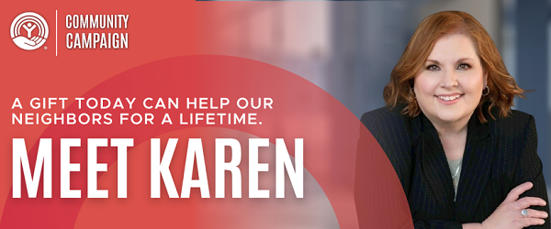
Hi <First Name>
Today, we are extending the [Company Name] United Way of Greater St. Louis campaign. Unite with us to guide neighbors like Karen on their path to success.
When Karen was just 3 weeks old, her biological mother decided to terminate her parental rights and try to find someone who might be better equipped to take care of her. The fate of Karen’s future was uncertain. Fortunately, a United Way partner agency stepped in to facilitate an adoption for Karen to be united with a loving, caring family that gave her the support she needed to achieve success.
Today, Karen thrives in her career in business and project management and recently won the St. Louis Business Journal’s Innovation Fire Award. Because of the vital role that United Way played early on in her life, she has been a champion for United Way for the past 25 years – giving and volunteering for us as often as she can. A gift from you makes stories like Karen’s possible.
United Way supports a safety net of over 150 local nonprofits that ensures that our neighbors have the resources and support needed to live here and thrive.
If you have not pledged yet, please unite with us to empower our neighbors to overcome challenges and access the resources they need to succeed.
Thank you for impacting positive change throughout our region.

FOCUS AREA EMAILS

REASONS WE PARTNER
REF# RWPSTL
From: United Way of Greater St. Louis <epledge@unitedwaystl.org>
Subject: United for a Stronger St. Louis Region

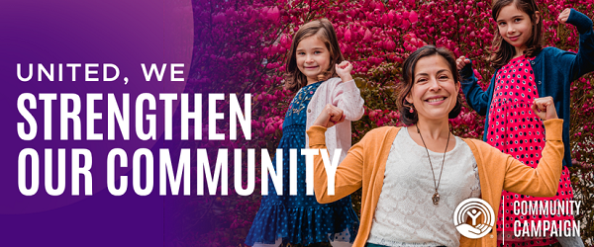
Hi <First Name>
United Way’s safety net of over 150 nonprofit partner agencies continues to navigate ongoing challenges and they need our support. Your collective gift makes a difference in the lives of over 1 million people every year – supporting programs, services, and initiatives that help meet their immediate and long-term needs.
United, we empower people to build brighter futures across our region – through one community, one campaign, one collective impact. It takes all of us working together, donating, and being involved to create real, lasting change for generations to come. Your support is vital to helping our five areas of impact:
- Basic needs
- Youth and early childhood success
- Financial mobility
- Health and well-being
- Community stability and crisis response
Each of these is made possible because of a shared commitment to empowering our neighbors.
United, we can continue working together to make the St. Louis region a better place for our neighbors to live and thrive. With your help, we can make this year’s campaign one of the most special ones yet!
Please consider making a gift to United Way of Greater St. Louis through this secure online pledge system.
Thank you for helping United Way strengthen the stability of our region.
Note: This donation link is unique to you to make pledging your gift easier. For your security, please do not forward this email.

PEOPLE HELPED EMAIL
REF# PHESTL
From: United Way of Greater St. Louis <epledge@unitedwaystl.org>
Subject: How You’re Changing Lives Through Your Support

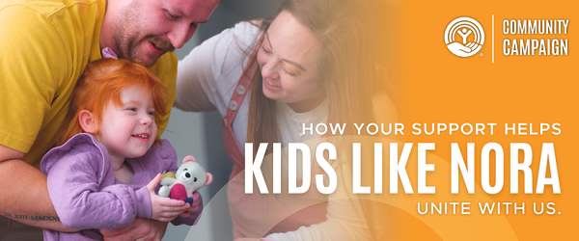
Hi <First Name>
When you support United Way of Greater St. Louis, you have the power to change the trajectory of someone’s life. Each year, we make a difference in the lives of over 1 million people.
Your gift to United Way helps people like:
- Jonah, who was born drug-exposed and abandoned. When a social worker called his grandparents, informing them of his condition, they began searching for a safe home for him. A United Way partner agency helped coordinate an adoption between two families of the same church—giving Jonah a permanent family and his grandparents the chance to meet him for the first time.
- Nora, who was diagnosed with autism at just 2-years-old. Her mother was heartbroken after learning about the fate of her daughter – she didn’t know what to do or who to turn to for help with her daughter. Fortunately, a United Way partner agency was there to offer Nora and her family support – helping Nora learn how to follow directions, socialize, participate in class, discover hobbies, and more. Today, Nora has built much more confidence and is thriving thanks to the programs and classes she participated in.
United Way supports a safety net of over 150 nonprofits that stabilize our local neighbors – helping them meet their immediate and long-term needs.
When you make a gift to support our neighbors, you are supporting children like Jonah and Nora.
This is also an opportunity to make a more significant, far-reaching impact by committing at the Leadership Giving level of $1,000 or more. By doing so, you become a part of a network of more than 7,000 leaders in our region and receive access to additional benefits, including annual events and programming.
Please unite with us by making a gift to United Way of Greater St. Louis through this secure online pledge system.
Thank you for empowering our neighbors.
Note: This donation link is unique to you to make pledging your gift easier. For your security, please do not forward this email.

STRONG COMMUNITIES EMAIL
Ref# SCESTL
From: United Way of Greater St. Louis <epledge@unitedwaystl.org>
Subject: Your Gift Strengthens Our Communities

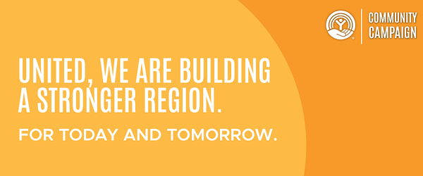
Hi <First Name>
The power of one lies in each person’s ability to spark change, and your gift through collective giving multiplies impact. When individuals, companies, labor unions, and agencies work together around a shared commitment to help others, our neighbors thrive.
Your willingness to unite with us helps support over 1 million people throughout the St. Louis region every year.
We still need your continued support; many of our neighbors are still struggling to make ends meet. In fact, 43% of individuals and families cannot meet their monthly basic needs. You help us provide funding and support to a safety net of over 150 nonprofits that help feed, clothe, and care for our neighbors in need.
United, we empower people and possibilities.
Please make a gift to United Way of Greater St. Louis through this secure online pledge system.
Thank you for helping us impact positive change throughout our region.
Note: This donation link is unique to you to make pledging your gift easier. For your security, please do not forward this email.

FINANCIAL STABILITY EMAIL
REF# FSESTL
From: United Way of Greater St. Louis <epledge@unitedwaystl.org>
Subject: Help Our Neighbors Achieve Financial Stability

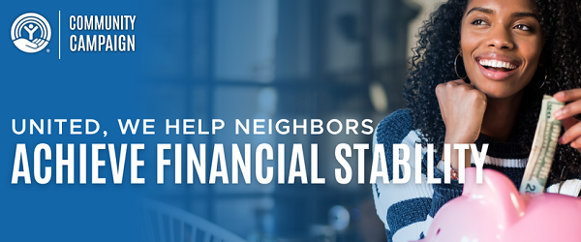
Hi <First Name>
Financial stability is a pivotal building block to success, opportunity and fulfillment. Right now, the cost of living makes financial stability difficult for many individuals and families throughout the St. Louis region.
United Way of Greater St. Louis provides financial mobility programs to help transform lives, create brighter futures and stronger communities, one person at a time. Last year alone, more than 37,000 individuals were empowered through these programs, gaining the tools and support they needed to secure stable employment and build a foundation for long-term success.
These efforts to empower people align with the mission and values of [Company Name], and your support is crucial. Every gift gives United Way programs and initiatives the capacity to help more people increase their income, reduce debt, and build their savings – steps that lead to long-term financial security and independence.
Unite with us by making a gift to United Way of Greater St. Louis through this secure online pledge system.
Thank you.
Note: This donation link is unique to you to make pledging your gift easier. For your security, please do not forward this email.

YOUTH SUCCESS EMAIL
REF# YSESTL
From: United Way of Greater St. Louis <epledge@unitedwaystl.org>
Subject: Empower Local Youth to Build a Brighter Tomorrow

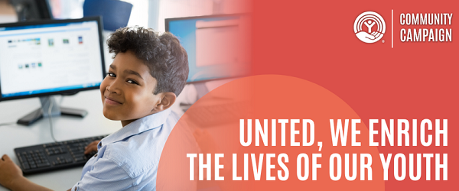
Hi <First Name>
Youth success is key to ensuring a stable future for our St. Louis region.
Each year, more than 400,000 children and youth thrive thanks to United Way of Greater St. Louis programs and partnerships. By supporting services like head start centers, youth development programs, and post-secondary access initiatives, United Way empowers young people to strengthen essential skills in math, reading, science, and technology – laying the foundation for long-term success.
Our safety net of local nonprofits needs your help supporting our youth. Youth face ongoing pressures and challenges every day and your gift supports programs and services that keep them on a successful path. These efforts align with [Company Name] mission and values, and that is why we are asking you to unite with us to help children and youth learn, grow, and feel safe.
Please invest in the success of our youth by making a gift to United Way of Greater St. Louis through this secure online pledge system.
Thank you.
Note: This donation link is unique to you to make pledging your gift easier. For your security, please do not forward this email.

HEALTH AND WELLBEING EMAIL
REF# HWESTL
From: United Way of Greater St. Louis <epledge@unitedwaystl.org>
Subject: A Community United for Better Health

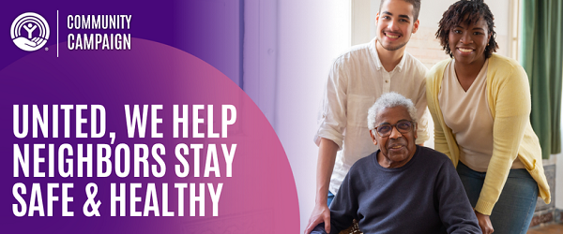
Hi <First Name>
United Way of Greater St. Louis focuses on ensuring that our local neighbors have the resources and support needed to live healthy, whole lives so they can pursue a better, brighter future. Our efforts to prioritize the health and well-being of individuals and families throughout the St. Louis region align with [Company Name's] values, and we hope this will encourage you to unite with us to help our neighbors stay healthy and supported.
Your gift helps United Way support our neighbors through services like senior care, disability assistance, mental health support, rehabilitation, and more.
Please join us in investing in the health and vitality of the St. Louis region by making a gift to United Way of Greater St. Louis through this secure online pledge system.
Thank you.
Note: This donation link is unique to you to make pledging your gift easier. For your security, please do not forward this email.

ESSENTIAL NEEDS EMAIL
Ref# ENESTL
From: United Way of Greater St. Louis <epledge@unitedwaystl.org>
Subject: United in Support of our Community

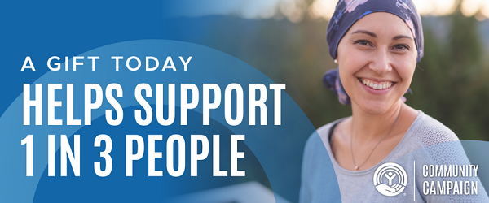
Hi <First Name>
Many individuals and families throughout the St. Louis region struggle to make ends meet from month to month. The need for your support is urgent; 43% of households in our region face challenges to meet essential needs like rent, utilities, food, transportation, and medical costs.
Through one collective impact, we have the power to move our neighbors from crisis to stability. This impact helps United Way meet essential needs and inspire hope.
You can change someone’s life through your gift. A pledge from you helps children, families, and seniors facing hardship.
You can help drive transformational change today by making a gift to United Way of Greater St. Louis through this secure online pledge system.
Thank you for helping us meet the needs of our community.
Note: This donation link is unique to you to make pledging your gift easier. For your security, please do not forward this email.

Specific Circumstances Emails

EMAIL FROM EXECUTIVE
Ref# EFESTL
From: <Executive Name> <epledge@unitedwaystl.org>
Subject: Build Better Communities for our Local Neighbors
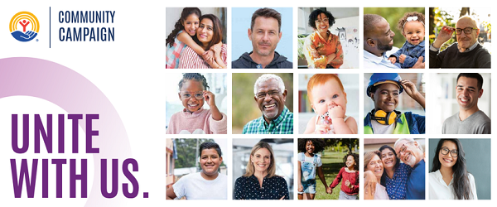
Dear <First Name>
For over a century, United Way of Greater St. Louis has been a constant source of support during good times and bad, and that is why [Company Name's] colleagues and I are proud to support their ongoing mission to help people live their best possible lives. United Way provides funding and support to a safety net of over 150 nonprofit partner agencies that help our neighbors get access to the resources and support needed to live here and thrive.
United, they help feed, clothe, and care for families across our region. Your gift helps United Way empower neighbors and build a better future.
Companies like ours have the power to move people from crisis to stability through our giving. I am excited about this opportunity to inspire hope and impact positive change throughout our region and I hope you’ll join me.
On behalf of our Leadership team, thank you. Your support of United Way of Greater St. Louis changes lives.
Sincerely,
[Executive Name]
Note: This donation link is unique to you to make pledging your gift easier. For your security, please do not forward this email.

EMAIL TO LEADERSHIP LEVEL DONORS OPTION 1
Ref# LLD1STL
From: United Way of Greater St. Louis <epledge@unitedwaystl.org>
Subject: Leadership Givers Inspire Long-Lasting Impact

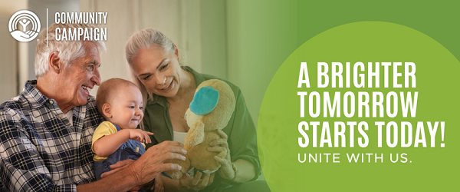
Dear <First Name>
Your support as a Leadership Giver gives you the opportunity to make a transformational impact that will build a foundation for a stronger future. A Leadership gift of $1,000 or more helps United Way of Greater St. Louis fund over 150 local nonprofits that ensure our neighbors in need are equipped with the resources and support needed to face ongoing and everyday challenges.
As a Leadership Giver, you have the power to make a significant, far-reaching impact while also gaining access to professional development, volunteering and networking events with other local professionals and community leaders who share your passion for helping people. You will also have access to tax-smart and planned giving support that we only offer to you as a Leadership Giver.
Please consider uniting with us through the Leadership Giving Societies to join more than 7,000 diverse and community-focused leaders committed to investing in United Way of Greater St. Louis and our mission to help people live their best possible lives.
Thank you for going above and beyond to ensure our neighbors stay safe, healthy, and supported.
Note: This donation link is unique to you to make pledging your gift easier. For your security, please do not forward this email.

EMAIL TO LEADERSHIP LEVEL DONORS OPTION 2
Ref# LLD2STL
From: United Way of Greater St. Louis <epledge@unitedwaystl.org>
Subject: Renew Your United Way of Greater St. Louis Leadership Gift

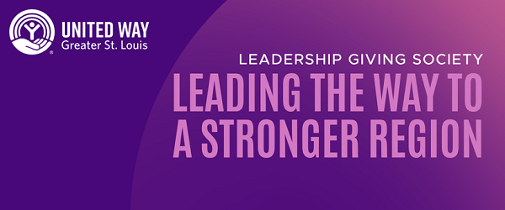
Hi <First Name>
As a United Way of Greater St. Louis Leadership Giver, you lead our community toward a future of hope, change, and help for our neighbors in need. Your willingness to take the extra step to support our neighbors gives people like Jodie hope during a dark time.
Jodie had just retired and was looking forward to living out her golden years in peace until a devastating cancer diagnosis derailed her plans. She didn’t know what to do – the diagnosis felt like a death sentence. Fortunately, a United Way partner agency provided a mental and physical wellness program for people with cancer diagnoses that gave her the opportunity to build strength physically, mentally and emotionally. Through this program, she met other people living with cancer who were surviving and thriving, and eventually she was convinced she could do the same.
Leadership Givers like you give Jodie hope for a better future.
Today, we ask you to unite with us again through a gift of $1,000 or more as a Leadership Giver. When you make this pledge, you join a network of over 7,000 local leaders and enjoy access to exclusive Leadership opportunities like professional development events, volunteering, and networking opportunities alongside professionals who share a passion for helping people. You will also have access to tax-smart and planned giving support that we only offer to you as a Leadership Giver.
Thank you for your leadership.

EMAIL TO LAST YEAR’S DONORS
Ref# LYDSTL
From: United Way of Greater St. Louis <epledge@unitedwaystl.org>
Subject: Unite With Us Again for the Greater Good of our Region

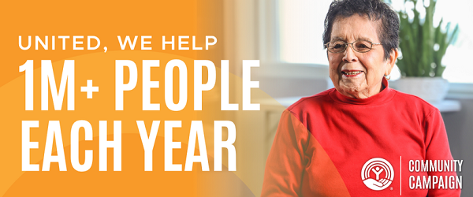
Hi <First Name>
We need your continuous support as we help our neighbors who are facing overwhelming obstacles. Over 40% of households in our region struggle to meet essential needs like rent, utilities, food, transportation, and medical costs.
Thank you for supporting our community campaign last year. Your support made a tangible difference, helping us meet both immediate and long-term needs for our neighbors.
Because of your support, United Way of Greater St. Louis remains one of the top United Way campaigns in the nation, with local fundraising results exceeding $3 billion, a transformative collective effort! This milestone reflects the outstanding generosity of our community. We are proud of how far we’ve come, but there is still much more work to be done.
Given our community’s ongoing challenges, we are asking you to unite with us again to build strong, resilient communities where everyone can thrive.
When you give a gift to United Way of Greater St. Louis, you are helping us fulfill our mission to help people live their best possible lives. With your support, we are able to help more than 1 million people every year. Every dollar you contribute directly supports over 150 nonprofits, programs, and initiatives that help our neighbors in need. Because of your support:
- Individuals and families rebuilt their lives with dignity and resilience after crisis or disaster.
- Our neighbors achieved stability through having their essential needs met.
- Individuals were equipped with resources to build long-term financial security.
- People got access to quality healthcare services that promoted overall wellbeing.
Through our campaign, we can unite to make one big collective impact that will have the power to transform lives. United, we empower people and possibility.
Please join us again this year by pledging today to United Way of Greater St. Louis.
Thank you.
Note: This donation link is unique to you to make pledging your gift easier. For your security, please do not forward this email.

EMAIL TO NON-DONORS
Ref# NDNSTL
From: United Way of Greater St. Louis <epledge@unitedwaystl.org>
Subject: Unite With Us to Create Sustainable Impact Across Our Community

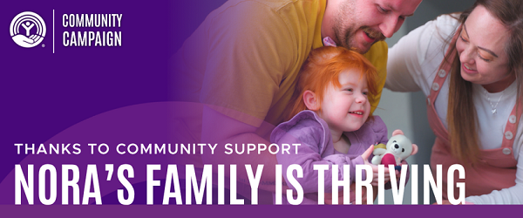

Hi <First Name>
United Way of Greater St. Louis unites the community with one goal in mind – helping people live their best possible lives.
Our founders, a small group of volunteers in 1922, believed that by working together and giving collectively, they could help more people. More than a century later, people across the greater St. Louis community continue striving each year to make the region a better place to live.
This continued generosity will inspire hope and help move many of our neighbors from crisis to stability. The need for support is urgent, with 43% of households in our region facing challenges to meet essential needs like rent, utilities, food, transportation, and medical costs.
Unite with us so we can ensure our neighbors have the resources they need to live here and thrive. Please pledge a gift to United Way of Greater St. Louis through this secure online pledge system.
Thank you for helping us amplify lasting change throughout our community.
Note: This donation link is unique to you to make pledging your gift easier. For your security, please do not forward this email.

