List of Questions
The next sections of the guide provide a detailed look at everything United Way will be asking your agency about in the Renewal Application.
**Note: Many questions in the renewal application are conditional based on the responses to the questions above it. As a result, some of the questions listed here may not appear for you while filling out the form.**

Administrative Profile

1. Eligibility Documents
Were there been any updates to the following documents or policies in 2021? If yes, please upload the updated document(s).
- Federal 501(c)(3) Tax Determination Letter
- Illinois or Missouri Certificate of Corporate Good Standing
- Agency policy for background checks on staff and/or volunteers (and if applicable, policies on child abuse and neglect screenings)
- Agency policy on non-discrimination in hiring and service delivery
- Agency policy on privacy protection practices
Do you agree to the following anti-terrorism certification in compliance with the USA Patriot Act?:
In compliance with the USA Patriot Act and other counterterrorism laws and United Way World wide's recommendation, the United Way of Greater St. Louis requires that the Executive Director of each member agency annually certify on behalf of the member agency that all United Way funds and donations will be used in compliance with all applicable anti- terrorist financing and asset control laws, statutes, and executive orders.

2. Briefly describe the work of your agency in 25 words or less. (25 Word Limit)
3. Please provide your organizational leader's most up to date contact information.
4. Name and contact information for the agency staff member who oversees the following (if applicable):
- Policy and/or advocacy work
- Volunteers
- United Way Employee Campaign Coordinator
- United Way Campaign Champion

Administration

5. Is your agency accredited or subject to review by your national organization? If yes, please list the accrediting body(ies) and expiration date(s) and/or your dues formula to your national organization. (500 word limit)
6. Has your agency had any legal, ethical, safety, or regulatory issues from January 1st to December 31st 2021 that we should be aware of? If yes, please explain. (500 word limit)
7. Has your agency had any official complaints or grievances from January 1st-December 31st? If yes, how many, and please explain. (500 word limit)
8. Enter the total number of people who were employed at any time from January 1st to December 31st 2021
9. What is the approximate number of Full Time Equivalent (FTE) positions normally employed?
Note: FTE is defined as the number of total hours worked divided by the maximum number of compensable hours in a work year as defined by law. For example, if the work year is defined as 2,080 hours, then one worker occupying a paid full-time job is equivalent to one FTE. Two employees working for 1,040 hours each are equivalent to one FTE between the two of them.
10. What is the approximate number of Part Time positions normally employed?
11. Are the agency’s staff members diverse (e.g., age, sex, race) and reflective of the community served? Please explain (500 word limit)
12. How many episodic volunteers, who came once or very few times for a particular event or purpose, did your agency have in from January 1st to December 31st?
13, How many ongoing volunteers does your agency have? (direct services and/or admin).
16. Over the past year, how has the agency cultivated and prioritized diversity, equity, and inclusion in the workplace (i.e. new policies and procedures, trainings, etc.?
17. Capacity building initiatives-Please provide the name, start date, end date, and status of up to 3 capacity building initiatives your agency has participated in from January 1-December 31st 2021. Enter “Ongoing” as end date for any incomplete activities.

Governance
1. Please provide updated Board Leader Information.
2. Were there any significant changes in your Board composition or activities in 2021? If yes, please explain. (500 word limit)
3. Did your organization conduct board meetings from January 1st-December 31st 2021? If so, how many meetings were held?
4. How many board volunteers does your agency have now?
5. How many committee volunteers does your agency have now?
6. Are the agency's board members diverse (e.g. age, sex, race) and reflective of the community served? Please explain. (500 word limit)
7. Are the agency's committee members diverse (e.g. age, sex, race) and reflective of the community served? Please explain. (500 word limit)
8. Is your agency currently participating in the Olin Board Fellow program?
9. Strategic plan-plan start date, end date, and description of goals. (500 word limit)
10. Does your organization have a systematic strategic planning process in which it uses the plan to inform operations?
Upload organizational chart.
Diversity, Equity, and Inclusion Efforts
1. Please describe your board’s strategic efforts in Diversity, Equity, and Inclusion across the following areas made in 2021.
2. What challenges and successes has your agency had in DEI? Please include whether any new policies been written
- Administration
- Governance
- Finance
- Program
3. Use this space to upload any documentation to share regarding your agency’s DEI efforts.
4. Please attach your completed board excel template below.

Finance
1. Was the agency in arrears in submitting any payroll taxes (employee or agency share) to any city, state or federal authorities in its most recently completed fiscal year? If yes, give details about tax delinquency and current status. (100 word limit)
2. Is the agency required to file an IRS Form 990 or 990EZ tax return? Please upload.
a) If yes, was the most recent IRS Form 990/990EZ tax return submitted on time or within an extension period approved by the IRS?
b) If no, provide details regarding late IRS Form 990/990EZ tax return submission. (100 word limit)
Please upload your agency's most recent Federal Form 990.
4. Please list any significant changes in the agency's financial situation for the current fiscal year. (500 word limit)
5. How did the agency utilize its United Way dollars in 2021?
6. What percentage of the 2022 United Way allocation award has been utilized to date? Note explanation if needed. (250 word limit)
7. Please provide an update regarding the agency’s most recent budget to actual results.
Please upload a copy of the agency’s quarterly financials through the most recently completed quarter.
Please upload your agency's most recent Federal Form 990.

Program
Please explain any major changes to your agency’s programs and services or general operations made due to factors related to Covid-19. How do these changes affect plans for the future? (1000 word limit)
How does your agency determine appropriate targets for the number of service delivery units in each program? (500 word limit)
How often does your agency re-evaluate targets for the number of service delivery units in each program?
Does your agency collect demographic data on all direct clients (gender, race/ethnicity, age, income, etc.)? If yes, what is the process for collecting this data (500 word limit)
Total number of direct clients that reside in UW service area served by your agency from January 1st 2021-December 31st 2021.
Describe a service or good provided by your agency that the following monetary amounts would provide: $10, $50, $150, $500, $100 (For example, $10 will provide flu shots for 7 infants.)
Agency-Wide Clients Served to Date
Guidance Regarding Direct and Indirect Clients
Direct Clients
These clients generally receive extensive and/or long-term services in small groups or one-on-one. Intake records or other reliable methods of collecting information on these clients are maintained. Please note that if a client receives a core direct service provided by your agency, even if only once, and you have any demographic information, the client should likely be considered direct, but records should be maintained to the degree that the same client is not counted twice in the direct client total.
Indirect Clients
These clients generally receive one-time or infrequent services from the agency and the services may be provided in a group setting. Detailed records for each client are not maintained, although a basic count of the number of participants should be available. Demographic information is typically difficult or impossible to collect for indirect clients.
Total Direct Clients that reside in United Way Service Area served by your agency from January 1 to December 31st, 2021. This number should be agency wide without duplication of clients.
Total Indirect Clients served by your agency January 1 to December 31st, 2021
Client Demographics
Gender Identity-Please enter the number of clients served who identify as the following categories:
- Female
- Male
- Self Defined/Other
- Decline to Disclose
- Unknown
The sum of the numbers you enter will display in the box marked “total clients served.” This number should match “Total Direct Clients” above.
Ethnicity and Race Self Identification- Please enter the number of clients served who identify as the following categories:
- Asian
- Bi-Racial/Multi-Racial
- Black/African American
- Hispanic/Latino/Latinx
- Native American/Alaska Native
- Native Hawaiian/Other Pacific Islander
- White/Caucasian
- Decline to Disclose
- Unknown
The sum of the numbers you enter will display in the box marked “total clients served.” This number should match “Total Direct Clients” above.
Household Income-Please enter the number of clients served who identify as the following categories:
- $0-$9,999
- $10,000-$14,999
- $15,000-$19,999
- $20,000-$29,999
- $30,000-$49,999
- $50,000-$59,999
- $60,000-$100,000
- More than $100,000
- Decline to Disclose
- Unknown
Age-Please enter the number of clients served in the following categories.
- 0-2 Years Old
- 3-5 Years Old
- 6-9 Years Old
- 10-14 Years Old
- 15-19 Years Old
- 20-34 Years Old
- 35-54 Years Old
- 55-64 Years Old
- 65-74 Years Old
- 75-84 Years Old
- 85 Years and Older
- Decline to Disclose
- Unknown
The sum of the numbers you enter will display in the box marked “total clients served.” This number should match “Total Direct Clients” above.
Zip codes-Please enter the number of clients you serve that reside in each zip code listed.
62001 | 62002 | 62003 | 62006 | 62009 | 62010 | 62012 | 62013 | 62014 | 62016
62018 | 62021 | 62022 | 62023 | 62024 | 62025 | 62026 | 62027 | 62028 | 62030
62031 | 62033 | 62034 | 62035 | 62036 | 62037 | 62040 | 62044 | 62045 | 62046
62047 | 62048 | 62050 | 62052 | 62053 | 62054 | 62058 | 62059 | 62060 | 62061
62062 | 62063 | 62065 | 62067 | 62069 | 62070 | 62071 | 62074 | 62078 | 62079
62081 | 62082 | 62084 | 62085 | 62087 | 62088 | 62090 | 62092 | 62093 | 62095
62097 | 62098 | 62201 | 62202 | 62203 | 62204 | 62205 | 62206 | 62207 | 62208
62215 | 62216 | 62217 | 62218 | 62219 | 62220 | 62221 | 62222 | 62223 | 62225
62226 | 62230 | 62231 | 62232 | 62233 | 62234 | 62236 | 62237 | 62238 | 62239
62240 | 62241 | 62242 | 62243 | 62244 | 62245 | 62248 | 62249 | 62250 | 62252
62253 | 62254 | 62255 | 62256 | 62257 | 62258 | 62259 | 62260 | 62261 | 62264
62265 | 62266 | 62269 | 62271 | 62272 | 62277 | 62278 | 62279 | 62280 | 62281
62282 | 62283 | 62285 | 62286 | 62288 | 62289 | 62292 | 62293 | 62294 | 62295
62297 | 62298 | 62355 | 62361 | 62366 | 62511 | 62626 | 62630 | 62640 | 62649
62667 | 62672 | 62674 | 62683 | 62685 | 62690 | 62694 | 62801 | 62916 | 63001
63005 | 63006 | 63010 | 63011 | 63012 | 63013 | 63014 | 63015 | 63016 | 63017
63019 | 63020 | 63021 | 63022 | 63023 | 63024 | 63025 | 63026 | 63028 | 63030
63031 | 63032 | 63033 | 63034 | 63037 | 63038 | 63039 | 63040 | 63041 | 63042
63043 | 63044 | 63045 | 63047 | 63048 | 63049 | 63050 | 63051 | 63052 | 63053
63055 | 63056 | 63060 | 63061 | 63065 | 63066 | 63068 | 63069 | 63070 | 63071
63072 | 63073 | 63074 | 63077 | 63079 | 63080 | 63084 | 63087 | 63088 | 63089
63090 | 63091 | 63099 | 63101 | 63102 | 63103 | 63104 | 63105 | 63106 | 63107
63108 | 63109 | 63110 | 63111 | 63112 | 63113 | 63114 | 63115 | 63116 | 63117
63118 | 63119 | 63120 | 63121 | 63122 | 63123 | 63124 | 63125 | 63126 | 63127
63128 | 63129 | 63130 | 63131 | 63132 | 63133 | 63134 | 63135 | 63136 | 63137
63138 | 63139 | 63140 | 63141 | 63143 | 63144 | 63145 | 63146 | 63147 | 63150
63151 | 63155 | 63156 | 63157 | 63158 | 63160 | 63163 | 63164 | 63166 | 63167
63169 | 63171 | 63177 | 63178 | 63179 | 63180 | 63182 | 63188 | 63190 | 63195
63197 | 63198 | 63199 | 63301 | 63302 | 63303 | 63304 | 63332 | 63333 | 63334
63338 | 63341 | 63342 | 63343 | 63344 | 63346 | 63347 | 63348 | 63349 | 63351
63357 | 63362 | 63363 | 63365 | 63366 | 63367 | 63368 | 63369 | 63370 | 63373
63376 | 63377 | 63378 | 63379 | 63381 | 63383 | 63385 | 63386 | 63387 | 63389
63390 | 63627 | 65041 | 65441

The sum of the numbers you enter will display in the box marked “total clients served.” This number should match “Total Direct Clients” above.
Service Unit Costs
Describe a service or good provided by your agency that following monetary amounts would provide, including how many or how much would be provided.
(E.g. $10 will provide flu shots for 7 infants; $500 will provide a month of counseling sessions to a survivor of domestic violence; $1000 will provide a three-month job training program for a veteran)
- $10
- $50
- $150
- $500
- $1,000
The following questions will be asked for each program included in your agency’s Safety Net contract:
- Program Name
- What percentage of your agency’s 2021 United Way Allocation is dedicated to this program?
- Total number of direct clients that reside in UW service area served by this program from January 1st – December 31st 2021.
- Total number of indirect clients served by this program from January 1st
- - December 31st 2021.
Program Outcome
- Outcome Measured. Choose from list of 99 predefined outcomes. Click here to access list.
- Specific Target Population measured. For example, "Clients who completed 9 program sessions.”
- Measurement Tool/Method. For example,” Clients completed the SUCCESS inventory survey at the beginning of the program and after 1 year. Clients whose scores improved by 5 or more achieved this outcome."
- Frequency of Measurement
- Number of Clients Measured-enter zero if reporting on community level outcome.
- Number of Clients who Achieved the Outcome. This number cannot be greater than the number of clients measured.
- Did you have a target goal for the percentage of clients to achieve this outcome? If yes, please enter goal in text box.
You can add additional outcomes by clicking the “Add another outcome” link after the Program Outcome section of the page. The button is at the lower right corner of the section.
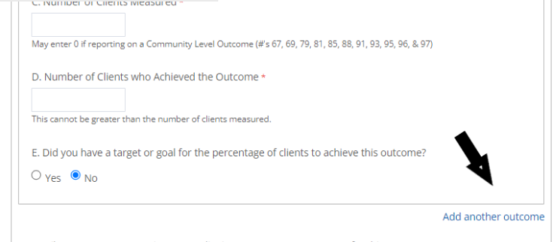
- Describe your agency's CQI process for this program.
- 1) How are outcomes used? What adjustments have been made as a result of findings?
- 2) What successes and challenges have you had with this program and how have you responded?

Employment Services Information-Does this program provide employment support services to help clients get jobs? If yes, answer the following questions:
- How many clients received employment support services in 2021?
- Which of the following types of employment services were offered in this program?
  - Job Readiness (soft skills: e.g., life skills, employment basics, GED classes, resume writing, interview skills, conducting job searches, etc.). If yes, how many clients received service?
  - Job Training (hard skills: e.g., Microsoft Office, custodial services training, health care services training, etc.). If yes, how many clients received service?
  - Job Development/Placement (matching clients with jobs). If yes, how many clients received services?
  - Job Retention/Employment Support (client follow up). If yes, how many clients received service?
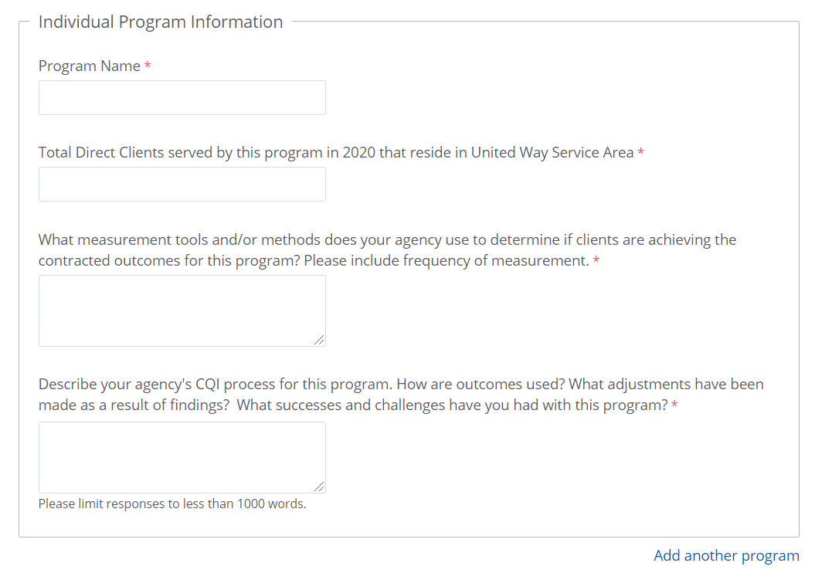
You can add additional programs by clicking the “Add another program” link after the Individual Program Information section of the page. The button is at the lower right corner of the section.

Renewal Questions
Would your agency like to be considered for 2023 funding? If no, why does your agency no longer wish to be considered for funding (500 word limit)? If yes, answer the following questions:
- What is your agency's projected total program expenses for fiscal year 2022?
- Does the agency foresee any projected changes in how it plans to utilize its United Way allocation award in 2023? (500 word limit)
- Does your agency anticipate any significant changes in your program for fiscal year 2022? If yes, please explain (500 word limit).
- Does your agency anticipate any significant changes in your governance structure for fiscal year 2022? If yes, please explain (500 word limit).
- Does your agency anticipate any significant changes in your finances for fiscal year 2022? If yes, please explain (500 word limit).
- Does your agency anticipate any significant changes in your administration structure for fiscal year 2022? If yes, please explain (500 word limit).

Acknowledgement
Please include the information of the primary person completing this form who should be our main contact for any questions about what is reported.
Acknowledgement Paragraph
Do you agree to the above statement? Please enter your initials.

